**Namespace:**

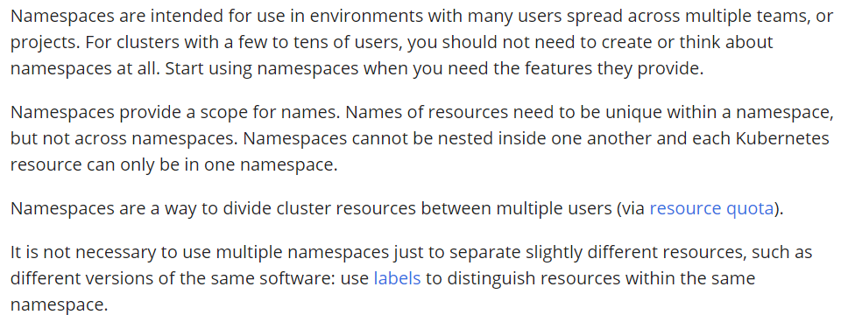

**Commands:**

To create namespace

* **Kubectl create namespace <namespace name>**

To delete the namespace

* **Kubectl delete namespace <name>**

Applying yaml to a namespace

* **Kubectl apply -f <yaml file> -n <namespace>**

Get pods or anything from namespace

* **Kubectl get pods -n <namespace>**

**Assign pods to nodes:**

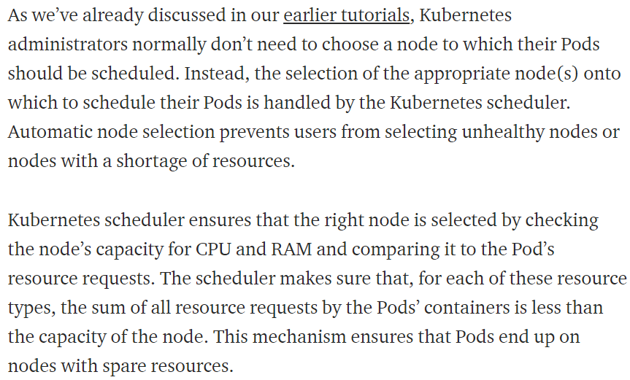

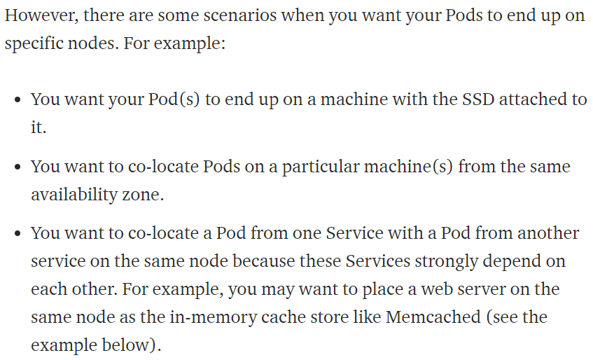

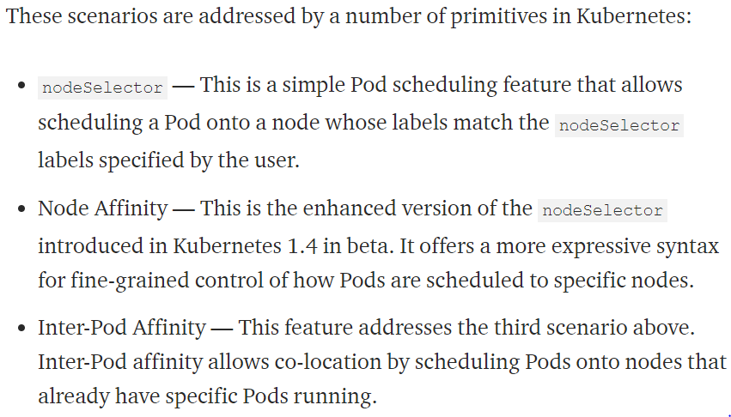

**nodeSelector:**

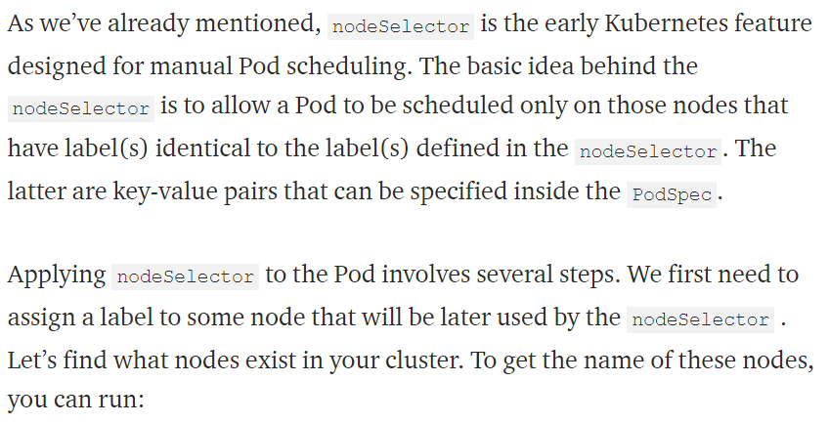

* We need to assign the nodes in nodeselector with label in pod yaml file.

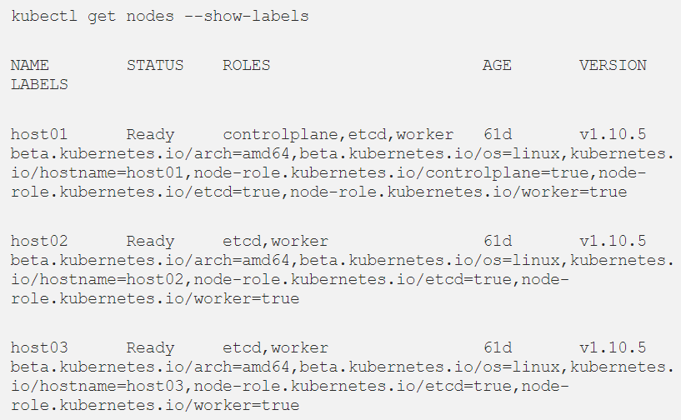

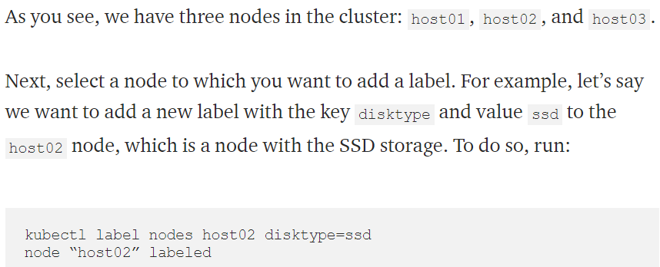

* Once the label is added to host2, we can see it as below.

